Thirtieth Sunday in Ordinary Time (Year C)  Reading I: Sir 35: 12-14, 16-18  Responsorial Psalm 134: 2-3, 17-18, 23  Reading II: 2 Timothy 4: 6-8, 16-18  Gospel: Luke 18: 9 - 14  Readings may be found on the US Bishop’s website:  https://bible.usccb.org/bible/readings/102322.cfm | 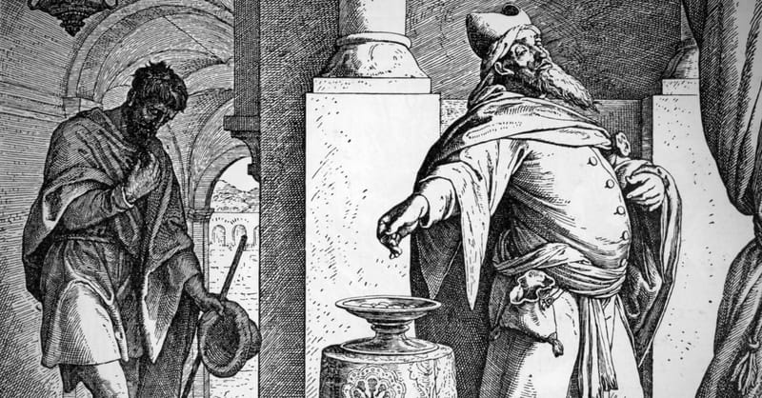  Pharisee and Tax Collector at prayer
The Gospel passage for today presents another parable about prayer. Two people go to the Temple to pray. The first is a Pharisee. The Pharisees were a social movement within Second Temple times. Their title is derived from the phrase for “set apart, separated.” They developed during the Babylonian exile where the Judeans needed to separate themselves from the Babylonian culture. The Pharisees presented an application of the Jewish Torah to everyday life in Judaism. The Pharisee in this parable begins with a hint of gratitude, “O God, I thank you…) He quickly shifts to naming all that he has done right in light of his understanding of the Torah. The focus is on his deeds and how he has kept the law. There is no recognition of what God has done nor any expression of his need for God. He is doing it on his own. He has earned God’s favor because of what he has achieved and is therefore better than others.
The other person in the story is a tax collector. Tax collectors were hated in Jewish society. They were considered part of the Roman oppression since they collected taxes for the Romans. They also received a part of the taxes for their efforts and thereby benefited from the unjust oppression of the people. Thirdly, the Roman coinage bore an image of one of the Roman gods and the image of Caesar. Both of which violated the command to make no graven image. Tax collectors were thus recognized as sinners.
The parable turns common expectations upside down. The one who is expected to be the good and virtuous one is not in a good relationship with God. His judgmental attitude leads to superiority over others and reliance upon himself. The one who is recognized as a public sinner has entered into a good relationship with God. He comes before God honestly, admitting that he is a sinner, and asks for forgiveness. He knows that he cannot do it on his own. He needs God.
The tax collector expresses humility. He knows himself and honestly states his failure. This honesty about one’s strengths and weaknesses is the foundation of religious life. God has blest each person with gifts and talents. Accepting these and placing them in the service of others is part of the Christian calling. Simultaneously, each person has weaknesses and wounds. Everyone needs God’s help to become whole and the help of others to live as a disciple. No one can do it all on one’s own strength. Jesus sent disciples out two by two. There is always the need to be in cooperation with others.
The Book of Sirach (Ecclesiasticus) was written about 200 years before Jesus and contains advice on living a life in harmony with God’s teachings. The passage for this Sunday offers perspectives on prayer. God is attentive to the prayers of every person and shows no partiality. Those of education and high standing do not have any advantage over the poor and marginalized people. This is shown in the parable that Jesus tells in the Gospel. While the widow and orphan did not often receive a hearing in ancient society, God hears their prayers. God is attentive to those who serve God and to those who have no standing in society. As expressed last week, one must wait upon God and be patient. Prayer does not manipulate God.
In the Letter to Timothy, Paul is presented as a model because of what he suffered. Even as the possibility of martyrdom grows stronger, Paul is not despairing because he knows that Christ has been with him and will continue to be with him. God had preserved him when others sought to kill him, when he was stoned, and when he was shipwrecked. God protected him that he might complete his mission of announcing the message of Christ to others. He uses an athletic metaphor to describe his journey. “I have competed well; I have finished the race; I have kept the faith.” The sufferings that Paul experienced were not signs that God abandoned him but an opportunity to participate in the sufferings of Christ. He is confident that God will continue to protect him and bring him to his ultimate goal of union with Christ.
While there are hints of the Pharisee talking, (Paul had been a Pharisee), he is not saying that he has done this on his own. It was Christ who stood by him and brought him through these difficulties. Paul concludes by giving praise to God for God’s faithfulness and saving help. Timothy is being urged to take Paul as a model. This same message applies to us. God will not abandon us but walks with us through every moment of life.

Reflection Questions:
What are some of the ways that you pray?
How do you respond to those who do not display the deeds of religious living?
What are some of the ways that you recognize God’s concern for you?
Where have you found strength in the challenges and sufferings of life?

Themes:
Virtue of Humility
Forms of Prayer
Admission of sinfulness
Salvation as a gift from God
God’s universal concern for each person

Prayer Suggestions:
For freedom of spirit: that God will help us surrender our pride, grow in our ability to be honest with ourselves, and truthfully acknowledge our strengths and weaknesses

For a spirit of gratitude: that we may recognize that all our gifts, possessions, and opportunities are gifts from God and place each of them in the service of God

For growth in prayer: that the Spirit will teach us how to pray so that we may deepen our intimacy with God and our acceptance of God’s kindness and forgiveness

For all who are suffering or experiencing persecution: that God will comfort and strengthen them and bring them safely through their trial

© Joseph Milner, 2022

